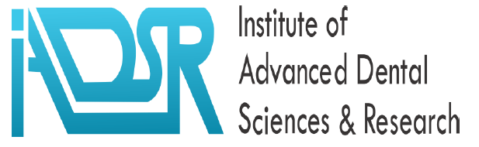
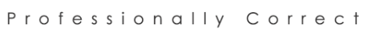

Institutional Profile

Institute of Advance Dental Sciences & Research (Pvt) Ltd.
The Institute of Advanced Dental Sciences & Research (IADSR) was established in 2000 as an Association of Persons (AoP) registered under Companies & Societies Registration Act, Government of the Punjab, Pakistan; and since 2020 it is registered with Securities & Exchange Commission of Pakistan as a Private Limited Company.
The organization is committed to uplift the standards of dentistry in the country to stand at par with global criteria with focus on Education, Research and Oral Health Care. We spent the first decade (2000-2010) of our existence in promoting all three components with local partners; most of the time taking a back seat as individual consultants. IADSR was officially launched as an independent organization in 2011 with its first international conference in Lahore.
Today, IADSR is the leading dental organizations in Pakistan and is recognized as the fastest growing organizer of academic meetings in the nation. During the last decade we has been responsible for organizing 30 very successful events to include seven international conferences and 23 symposia/seminars. We have conducted and managed over a hundred workshops and our international conferences have attracted over 10,000 participants. All academic events organized by us have exceeded expected participation. As a collaborating partner, we have also contributed in nationwide events such as the World Oral Health Day and symposia organized by other organization including the Pakistan Dental Association.
IADSR boasts a very strong in-country presence in the dental fraternity with institutional coordinators in all teaching dental institutions of the country; and have access to practically all national and a very large number of international experts.
IADSR has been working towards elevating the standards of dental care by targeting all general dental practitioners of the country through regular, organized and accredited CPD activities. There is a special focus on the fresh graduates for these programs.
In 2014, IADSR established a state-of-art training center to cater for 15 trainees at that time and initiated structured short (3-12 months; 2-4 sessions/month) courses in Advance General Dentistry; Advance Endodontics; Periodontics; Dental Implants and Research Methodologies. All these courses are accredited by the University of Health Sciences (UHS) and approved by the Pakistan Medical & Dental Council (PMDC)/ Pakistan Medical Commission (PMC) for CDE hours. We invite top clinicians and academicians from around the country and internationally to conduct these courses – each module of which has didactic and hands-on sessions. The students are assisted and facilitated to submit case reports on patients related to each module. This year we have designed short courses in Pediatric Dentistry, Endodontics; Fixed Prosthesis; Cosmetic Dentistry; and Minor Oral Surgery. These courses are very popular and highly sought after. We get students from all over the country and have also had a few graduates from Middle East attending some of our courses.

We expanded our training center in 2018 to accommodate up to 25 students at a time. Our Professional Diploma in Advance General Dentistry (PDAGD) is now an established program and by far the most popular course in the country. We are into our 18th course and more than 260 graduates have attended these courses in the last nine years. We are presently in the planning phase of establishing similar training centers across the coutry.
We have also developed a system of verifiable CPD hours/ points based on the international regulations and processes. We are working to get local and international academia on board to accredit these courses with Credit Accumulation & Transfer System (CATS); the weight-age of which would allow advanced standing admission in formal diploma / degree programs offered locally and globally.
We have been able to make substantial progress in achieving our targets. A series of CPD programs have been running in collaboration with various institutions of the country; the institute has advised and secured position for eighteen postgraduate students in the past five years; we have also been instrumental in initiating postgraduate teaching program in two local universities.
IADSR has provided consultancy to five universities to establish and stabilize undergraduate and postgraduate programs. It was the Lead consultant for University of Lahore in initiating and delivering their Masters in Medical Education program for the first four years of this program. The University of Faisalabad was provided consultancy to upgrade their undergraduate program and document their postgraduate program; over the last six years we have been able to improve the ranking of University Dental College from 11th in Punjab to 2nd; we have also completed documentation for their MPhil programs. More recently we provided consultancy to Superior University to establish Dental Section of Azra Naheed Dental College, Lahore; and Baqai Medical University, Karachi to establish their Public Health and Dentistry programs at Masters and PhD levels.
IADSR recently partnered with WHO-EMRO to develop an online course on Promotion of Oral Health. Our consultants have provided consultancy to WHO on oral health in Iran, Egypt, Yemen, Lebanon and Jordan.
We have been collaborating partners of Annual World Oral Health Day Events for the last five years. Celebrated; which are organized by the Dental News in collaboration with World Dental Federation (FDI); Asia Pacific Dental Association (APDFF); and Pakistan Dental Association (PDA).
Our collaborative partners in the past include South Asian Association of Medical Education; AuthorAid (UK); European Association of Cosmetic Dentistry; The Centre for Evidence-based Dentistry (CEBD), UK; Higher Education Commission; University of Lahore; Baqai Medical University, Dow University of Health Sciences; University of Health Sciences; University of Faisalabad; Ghandhara University; and many more.

Initially located at 189 Central Commercial Area, Sector DD, Phase IV, DHA. Lahore; IADSR Offices recently moved to a company owned 6,000 sq. ft. purpose-built facility on 22- Pine Avenue, Main Boulevard, Eden Villas II, Lahore. This facility includes the Center for Professional Development, a fully equipped training center with a conference hall to accommodate 30 people in workshop mode and 45 people in theatre setting. We have also established a fully equipped online teaching and learning center in our 1500 sq. ft. hall on the second floor.
This physical infrastructure is manned by an eighteen-member strong full-time team to include a dental team supported by marketing, management, computer experts, procurement, account and support personnel.

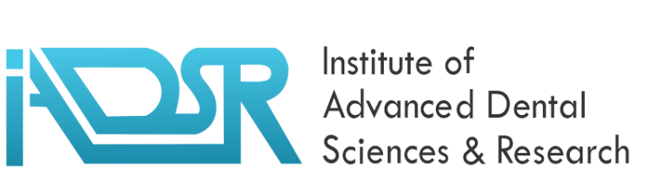

OUR VISION
To transform oral health landscape of the country through empowering health care professionals and the public

OUR MISSION
To improve oral health of the community by providing sustainable life changing opportunities to health care professionals & public through quality education, innovative research and evidence based clinical care

We achieve this mission by
-Doing the right things
-Doing things right
- The right person doing it

CORE VALUES
Integrity
Agility
Determination
Sustainability
Resilience

ACTIVITIES
International Conferences and Seminars
Professional & Skill Development Courses
Student Placements
Career Counselling & Placements for dentists
Research projects
Dental Practice Consultancy & Franchising

